QCL-FRM-6.08
REV#00
REV. DATE: 07-02-2023

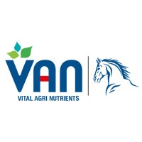


VAN QC LAB
RAW MATERIAL
QUA LITY CHECK REPORT
Instruments/services

Material: Flame Photometer Vender: Rays Technology
Date arrived 23 February 2024 Quantity: 1
SR/GRN No. LOT# N/A

S.NO | Descriptions | Parameters | Test result
 | Company name (Sherwood) | Na, K, Ca | OK
 | Working range (0-100ppm) | Na, K, Ca | OK
 | Quantity receive (1) | Good/ Bad | Good
4 | Certificate of analysis | N/A | N/A
5. | Receiving condition (any breakage) | Y/N | No
6. | MSDS/ log | Y/N | Yes
7 | Working | Satisfactory | Satisfy
8 | PNAC /QMS/Halal certificate | Y/N | No
9 | Service provide on time | Y/N | Yes

Accepted  Rejected

If rejected give reason:

____________ _____________ _____________
QC QCM P.M

